# Homework: HTML5 Forms

This document defines homework assignments from the [“Web Fundamentals (HTML & CSS)“ Course @ SoftUni](https://softuni.bg/courses/web-fundamentals/). Please submit as homework a single zip / 7z archive holding the source code of all below described problems.

## Simple Form

Create a HTML form like the image below (100% accuracy is not required). Put appropriate validation and placeholders.

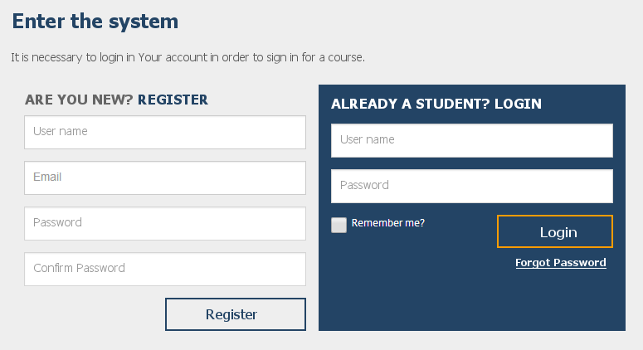

<body>

<div id="container">

<h3>Enter the system</h3>

<p>It is necessary to login Your account in order to sign in for a course.</p>

<form id="register">

<fieldset>

<header>are you new? <span class="register">register</span></header>

<input type="**text**" name="username" placeholder="User name" required/>

<input type="**emai**l" name="email" placeholder="Email" required/>

<input type="**password**" name="pass" placeholder="Password" required />

<input type="password" name="confirm-pass" placeholder="Confirm password" required />

<input type="**submit" value="Register**">

</fieldset>

</form>

<form id="login">

<fieldset>

<header>already a student? login</header>

<input type="text" name="username" placeholder="User name" required/>

<input type="password" name="pass" placeholder="Password" required />

<p><input type="**checkbox**" name="remember" placeholder="yes"><span class="remember">Remember me?</span></p>

<input type="submit" value="Login" />

<div><a href="#">Forgot Password</a></div>

</fieldset>

</form>

</div>

</body>

## Flight Order

Create a HTML page like the image below (100% accuracy is not required).

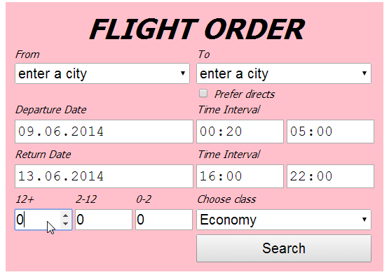

<body>

<form>

<fieldset>

<header>flight order</header>

<div id="from-to">

<div id="from">

<label for="from">From</label></br>

<select name="from-city" id="from">

<option>enter a city</option>

<option value="sofia">Sofia</option>

<option value="plovdiv">Plovdiv</option>

<option value="bourgas">Bourgas</option>

</select>

</div>

<div id="to">

<label for="to">To</label></br>

<select name="to-city" id="to">

<option>enter a city</option>

<option value="barcelona">Barcelona</option>

<option value="rio">Rio</option>

<option value="sidney">Sidney</option>

</select>

</br><input type="checkbox" name="prefer-direct" value="yes" id="flight"/>

<label for="flight">Prefer direct</label>

</div>

</div>

<div id="departure-info">

<div id="departure-date">

<label for="departure-date">Departure Date</label></br>

<input type="date" name="startDate" id="departure-date" value="01-01-2016"/>

</div>

<div id="departure-interval">

<label for="departure-interval">Time interval</label></br>

<input type="time" name="departure-interval-min" id="interval" value="00:20"/>

<input type="time" name="departure-interval-max" id="interval" value="05:00"/>

</div>

</div>

<div id="return-info">

<div id="return-date">

<label for="return-date">Return Date</label></br>

<input type="date" name="endDate" id="return-date" value="01-01-2016"/>

</div>

<div id="return-interval">

<label for="return-interval">Time interval</label><br/>

<input type="time" name="return-interval-min" id="interval" value="16:00"/>

<input type="time" name="return-interval-max" id="interval" value="22:00"/>

</div>

</div>

<div id="additional-info">

<div id="teenagers">

<label for="teenager">12+</label><br/>

<input type="number" min="0" max="10" value="0" />

</div>

<div id="children">

<label for="children">2-12</label><br/>

<input type="number" min="0" max="10" value="0" />

</div>

<div id="babies">

<label for="babies">0-2</label><br/>

<input type="number" min="0" max="10" value="0" />

</div>

<div id="class">

<label for="class">Choose class</label><br/>

<select name="choose-class" id="class">

<option value="economy">Economy</option>

<option value="business">Business</option>

<option value="vip">VIP</option>

</select>

</div>

</div>

<div>

<input type="submit" value="Search" />

</div>

</fieldset>

</form>

</body>

## WordPress Theme

Create a HTML page like the image below (100% accuracy is not required).

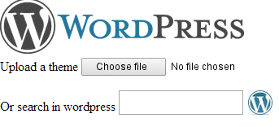

<body>

<form id="wordpress-form">

<img src="wordpress2.png" id="logo"/>

<div id="upload-theme">

<label for="upload">Upload a theme</label>

<input type="file" id="upload"/>

</div>

<div id="search">

<label for="search-theme" type="search">Or search for</label>

<input type="search" id="search-theme"></input>

<input type="image" src="search-logo.png" id="search-logo"/>

</div>

</form>

</body>

## Fakebook Register Form

Create a HTML page like the image below (100% accuracy is not required). Make the fields on the right required. Use field validation for email and phone number. Set some tab indexes. Use labels where possible.

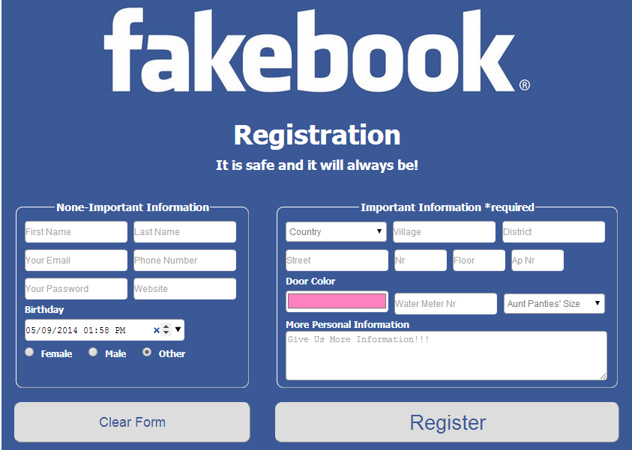

<body>

<div id="wrapper">

<h1>fakebook<span id="small-copy">&reg;</span></h1>

<h3>Registration</h3>

<h6>It is safe and it will always be!</h6>

<form>

<div id="left-side">

<fieldset id="none-important">

<legend>None-Important Information</legend>

<input type="text" placeholder="First Name"/>

<input type="text" placeholder="Last Name"/>

<input type="email" placeholder="Your Email"/>

<input type="tel" placeholder="Phone Number"/>

<input type="password" placeholder="Your Password"/>

<input type="url" placeholder="Website"/>

<label for="birth-date">Birthday</label><br/>

<input type="date" id="birth-date"/><br/>

<div class="gender-buttons">

<input type="radio" name="gender" id="female">

<label for="female" name="gender">Female</label>

<input type="radio" name="gender" id="male">

<label for="male" name="gender">Male</label>

<input type="radio" name="gender" id="other">

<label for="other" name="gender">Other</label>

</div>

</fieldset>

<input type="reset" value="Clear Form" />

</div>

<div id="right-side">

<fieldset id="important">

<legend>Important Information *required</legend>

<select name="country" required="true" class="oneThird">

<option disabled="disabled" selected="selected" value="" >Country</option>

<option value="bulgaria">Bulgaria</option>

<option value="italy">Italy</option>

<option value="usa">USA</option>

</select>

<input type="text" placeholder="Village" class="oneThird" required="true" />

<input type="text" placeholder="District" required="true" class="oneThird" />

<input type="text" placeholder="Street" required="true" class="oneThird" />

<input type="number" placeholder="Nr" required="true" class="oneForth"/>

<input type="text" placeholder="Floor" required="true" class="oneForth" />

<input type="text" placeholder="Ap.Nr" required="true" class="oneForth"><br/>

<label for="door-color" class="oneThird">Door Color</label><br/>

<input type="color" name="door-color" id="door-color" value="#FF8000" required="true" class="oneThird" />

<input type="text" placeholder="Water Meter Nr" required="true" class="oneThird" name="meter"/>

<select name="aunt" required="true" class="oneThird">

<option disabled="disabled" selected="selected" value="">Aunt Panties'size</option>

<option value="s">S</option>

<option value="m">M</option>

<option value="l">L</option>

</select>

<label for="more-info">More Personal Information</label>

<textarea id="more-info" placeholder="Give Us More Information!!!"></textarea><br/>

</fieldset>

<input type="submit" value="Register" />

</div>

</form>

</div>

</body>

## Laptop Choice

Create a HTML page like the image below (100% accuracy is not required). You don’t need to optimize the sliders for all browsers. Each group of elements, marked in red, must be a button that opens a link by choice. *The red rectangle is not a part of the assignment.*

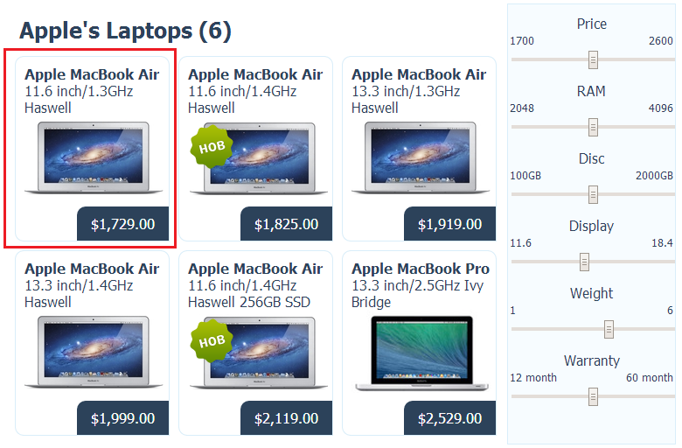

<body>

<div id="wrapper">

<div id="laptops">

<header>Apple's Laptops (6)</header>

<button onclick="window.open('http://laptop.bg')">

<h3>Apple MacBook Air</h3>

<p>11.6 inch/1.3GHz Haswell</p>

<img class="image" src="resources/macbook-1.png" alt="laptop-image"/>

<div class="price">$1.729.00</div>

</button>

<button onclick="window.open('http://laptop.bg')">

<h3>Apple MacBook Air</h3>

<p>11.6 inch/1.4GHz Haswell</p>

<img class="image" src="resources/macbook-1.png" alt="laptop-image"/>

<div class="price">$1.825.00</div>

</button>

<button onclick="window.open('http://laptop.bg')">

<h3>Apple MacBook Air</h3>

<p>13.3 inch/1.3GHz Haswell</p>

<img class="image" src="resources/macbook-1.png" alt="laptop-image"/>

<div class="price">$1.919.00</div>

</button>

<button onclick="window.open('http://laptop.bg')">

<h3>Apple MacBook Air</h3>

<p>13.3 inch/1.4GHz Haswell</p>

<img class="image" src="resources/macbook-1.png" alt="laptop-image"/>

<div class="price">$1.999.00</div>

</button>

<button onclick="window.open('http://laptop.bg')">

<h3>Apple MacBook Air</h3>

<p>11.6 inch/1.4GHz Haswell 256GB SSD</p>

<img class="image" src="resources/macbook-1.png" alt="laptop-image"/>

<div class="price">$2.119.00</div>

</button>

<button onclick="window.open('http://laptop.bg')">

<h3>Apple MacBook Pro</h3>

<p>13.3 inch/2.5GHz Ivy Bridge</p>

<img class="image" src="resources/macbook-3.png" alt="laptop-image"/>

<div class="price">$2.529.00</div>

</button>

</div>

<div id="range">

<h3>Price</h3>

<div class="min-max">1700<div class="max">2600</div></div>

<input type="range" min="1700" max="2600" step="100" name=" price" id="price" />

<h3>RAM</h3>

<div class="min-max">2048<div class="max">4096</div></div>

<input type="range" min="2048" max="4096" step="1024" name="ram" id="ram" />

<h3>Disc</h3>

<div class="min-max">100GB<div class="max">2000GB</div></div>

<input type="range" min="100" max="2000" step="200" name="disc" id="disc" />

<h3>Display</h3>

<div class="min-max">11.6<div class="max">18.4</div></div>

<input type="range" min="11.6" max="18.4" step="0.5" name="display" id="display" />

<h3>Weight</h3>

<div class="min-max">1<div class="max">6</div></div>

<input type="range" min="1" max="6" step="0.1" name="weight" id="weight" />

<h3>Warranty</h3>

<div class="min-max">12 month<div class="max">60 month</div> </div>

<input type="range" min="12" max="60" step="3" name="warranty" id="warranty" />

</div>

</div>

</body>

# Exam problems.**

**All of the problems below are given on Web Fundamentals (HTML & CSS) Practical Exams.**

**You are not obligated** to submit any of them in your homework. We highly recommend you to try solving some or all of them so you can be well prepared for the upcoming exam. If you still find those problems too hard for solving it’s very useful to **check** and **understand** the solutions.

## * Room Reservation

Create a Web form (HTML5 + CSS3 + images) that looks and behaves like the screenshots below:

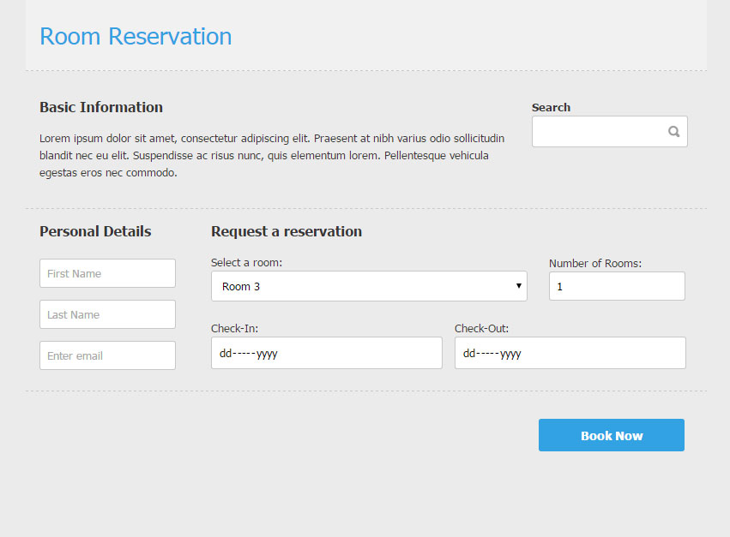

### Input

You are given the above screenshots and all required images.

### Output

The output should be valid HTML5 + CSS3 + images that implement the above Web form.

### Constraints

* Font: 13px Tahoma, Helvetica, sans-serif.
* Title: 28px; Subtitle: 16px; Tahoma, Helvetica, sans-serif.
* Content max-width: 800px;
* The icon in search field is a button.
* “Select a room” is drop-down.
* “Number of rooms” is number field.
* “Check-in” and “Check-out” are date fields.
* Other fields are text.
* Form validation is not required.
* The site should open correctly in Chrome 35.
* Responsive design is not required.
* Pixel-perfect implementation is not required.

## *Search Job

Create a Web site (HTML5 + CSS3 + images) that looks and behaves like the screenshots below:

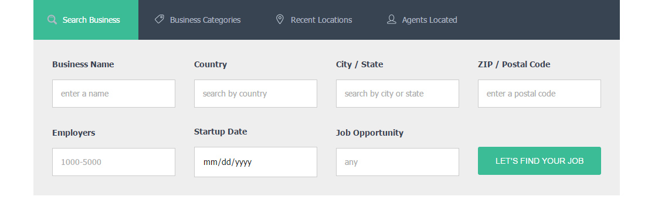

* The hand cursors in the screenshots show what happens when the mouse moves over certain elements.

### Input

You are given two screenshots, images + the texts on the site.

### Output

The output should be valid HTML5 + CSS3 + images that implement the above Web site.

### Constraints

* Fonts:
  + Site content: Tahoma, Helvetica, sans-serif; 14px.
* Site content: fixed width 1000px.
* The site should open correctly in Chrome 35+.
* Responsive design is not required.
* Pixel-perfect implementation is not required.
* Take the colors from the pictures with color picker.

## *Login Form

Create a Web form (HTML5 + CSS3 + images) that looks and behaves like the screenshots below:

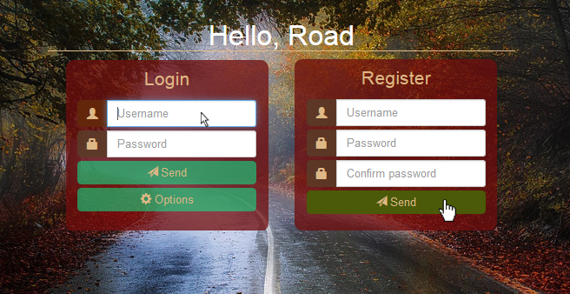

### Input

You are given the above screenshots + the background image.

### Output

The cursors in the screenshots demonstrate the form's behavior, do **NOT** implement them.

The output should be valid HTML5 + CSS3 + images that implement the above Web form.

### Constraints

* Main font: Tahoma, Helvetica, sans-serif.
* Main container for both forms must be 530 x 350px.
* Main container should be in the center of the Web page.
* The background image should cover the entire Web page.
* Form validation **is not required**.
* The site should open correctly in Chrome 35 and above.
* Responsive design **is not required**.
* Pixel-perfect implementation **is not required**.

## *Free Account

https://github.com/Filkolev/SoftUni/tree/master/Web%20Fundamentals/Exams/Exam-2014-11-01/03

Create a Web form (HTML5 + CSS3 + images) that looks and behaves like the screenshots below:

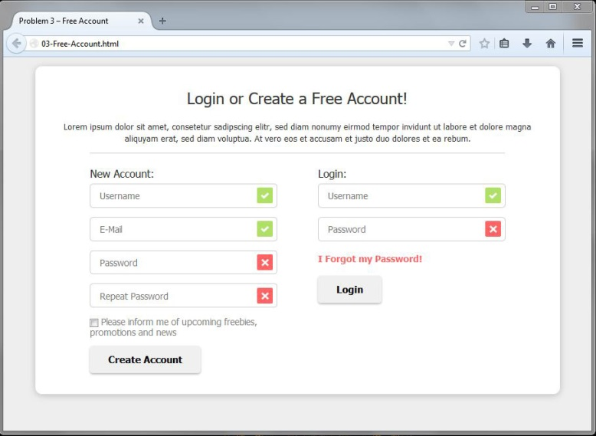 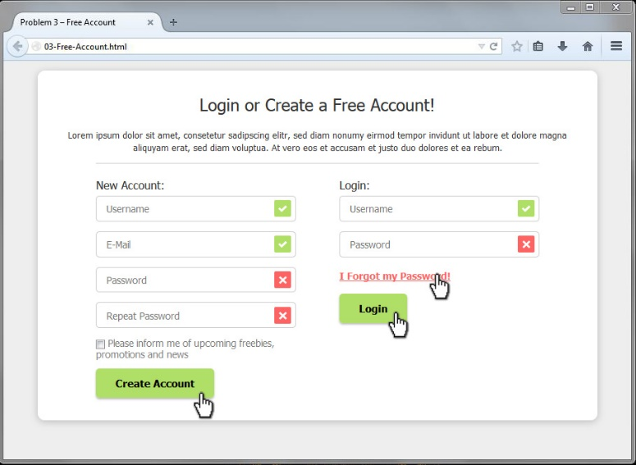

### Input

You are given the above screenshots and all required images.

### Output

The output should be valid HTML5 + CSS3 + images that implement the above Web form.

* You do not need to implement form validation. The images at the end of the fields are static – do not depend on the text inside the field.

### Constraints

* Font: Tahoma, Helvetica, sans-serif.
* Site content: fixed width 800px.
* Heading font-size: 24px.
* Form validation is not required.
* The site should open correctly in Chrome 38.
* Responsive design is not required.
* Pixel-perfect implementation is not required.